PRESS CONTACT: Nancy Richards – 917-873-6389 (cell)/nancy@northcoastrep.org
MEDIA PAGE: www.northcoastrep.org/press
PHOTOS BY: Aaron Rumley

FOR IMMEDIATE RELEASE, PLEASE:
FREUD’S LAST SESSION IGNITES LIVELY, WITTY DEBATE
IN OFF BROADWAY HIT PRESENTED AT NORTH COAST REP
BY MARK ST. GERMAIN
Performances Beginning Wednesday, Oct. 15
With Opening Night, Saturday, Oct. 18, at 8 pm
Running Through Sunday, Nov. 9
Directed by DAVID ELLENSTEIN
This production is made possible by the generosity of Professor Marianne McDonald, Ph.D.

Near the end of his life, Sigmund Freud invites a final visitor, the writer C. S. Lewis, who will soon gain wide fame for his new book, “The Lion, the Witch and the Wardrobe.” Not only are their views highly divergent – Freud is a committed atheist; Lewis, once an atheist, is now a committed Anglican – the two are a study in contrasts. Freud is irascible and adamantly opinionated; Lewis is sunny, warm and unflappable. The two men engage in a far-ranging, lively, witty debate touching on love, religion, politics and the meaning of life. Playwright Mark St. Germain infuses this fictional meeting with gentle humor and sharp dialogue. Winner of the 2011 Best Play Award by the Off Broadway Alliance, this San Diego premiere is a must-see for the discerning theatre lover.

Director David Ellenstein directs Michael Santo* and Bruce Turk* in Freud’s Last Session. The design staff includes Marty Burnett (Scenic Design), Matt Novotny (Lighting Design), Alina Bokovikova (Costume Design), and Melanie Chen (Sound Design), Benjamin Cole (Props Design) comprise the crew. Cindy Rumley* stage manages.
*The actor or stage manager appears through the courtesy of Actors’ Equity Association, the union of professional actors and stage managers in the United States.

FREUD’S LAST SESSION previews begin Wednesday, October 15. Opening Night on Saturday, October 18 at 8pm includes a post-show reception. There will be a special talkback on Friday, October 24, with the cast and artistic director. It will play Wednesdays at 7pm, Thursdays through Saturdays at 8pm, Saturday and Sunday matinees at 2pm with Sundays at 7pm, through NOVEMBER 9, 2014. (See Schedule below.) North Coast Repertory Theatre is located at 987 Lomas Santa Fe Drive, Ste D, Solana Beach, CA 92075. Tickets: Opening Night - $54, Previews- $37; Week Nights - $44; Sat. Eve. & Sun. Mat.- $48; Sat. Mat. & Sun. Night - $41. Seniors, Students, Military - $3 off admission. Call 858-481-1055 or visit www.northcoastrep.org to purchase tickets.

For background information and photos, go to www.northcoastrep.org/press.
Please follow North Coast Repertory Theatre on social media as well on Facebook at https://www.facebook.com/pages/North-Coast-Rep/128553240497901
Twitter: https://twitter.com/NorthCoastRep
YouTube: http://www.youtube.com/user/NCRTheatre?ob=0

Busy director David Ellenstein, playwright Mark St Germain and his cast members are available for interviews by phone, in person, and in-studio. For more information and to arrange interviews or press tickets, please contact Nancy Richards at nancy@northcoastrep.org, or 917-873-6389 cell.
FACT SHEET
WHAT: NORTH COAST REPERTORY THEATRE presents
FREUD’S LAST SESSION
Written by MARK ST. GERMAIN
Directed by David Ellenstein
CAST: Michael Santo* and Bruce Turk*

WHERE: North Coast Repertory Theatre
987 Lomas Santa Fe Drive, Ste. D
Solana Beach, CA 92075

SCHEDULE*: Previews: October 15-17, 2014
Opens: October 18, 2014, 8 pm
Closes: November 9, 2014
Wed. @ 7pm, Thurs-Sat @ 8PM; Sat & Sun @ 2PM, Sun @7pm
Talkback with cast & director: October 24, 2014

PRICES: Previews $37.00
Opening Night $54.00
Week Nights $44.00
Sat. Matinees & Sunday Nights $41.00
Sat. Nights & Sunday Matinees $48.00

DISCOUNTS: Seniors, Students, Military $3.00 off admission

BOX OFFICE (858) 481-1055 or www.northcoastrep.org

October/NOVEMBER
SUN | MON | TUE | WED | THU | FRI | SAT
 |  |  | 15  Preview 8pm | 16  Preview 8pm | 17  Preview 8pm | 18  OPENING  8pm
19  2pm & 7pm | 20 | 21 | 22  7pm | 23  8pm | 24  8pm Talkback | 25  2pm & 8pm
26  2pm & 7pm | 27 | 28 | 29  7pm | 30  8pm | 31  8pm | NOV 1  2pm & 8pm
2  2pm & 7pm | 3 | 4 | 5  7pm | 6  8pm | 7  8pm | 8  2pm & 8pm
9
2pm

BACKGROUND:
North Coast Repertory Theatre’s 2014-2015 -Season 33 celebrates the holiday season with a novel version of This Wonderful Life (December 10 – 28). James Leaming (“Who Am I This Time?”) returns to North Coast Rep with the San Diego premiere of his dazzling one-man tour-de-force based on the perennial favorite, “It’s a Wonderful Life.” In an amazing display of physical and verbal virtuosity, Leaming brings to life over 32 familiar characters. His Jimmy Stewart-inspired George Bailey leads the impressively portrayed cast of characters from Bedford Falls including Clarence the Angel, Mary, Zuzu and all the colorful townsfolk who rely on him to save them from the greedy Henry Potter. In cities across the nation, Leaming has left audiences cheering. 2015 kicks off with a San Diego musical premiere, Gunmetal Blues (January 14- February 8), a wildly entertaining musical spoof of 1940s film noir laced with mystery, music and demolished dreams. In the best Raymond Chandler tradition, the scene is set in the seedy, smoky Red Eye Lounge, where we meet a tough, trench-coated private eye, blondes and more blondes, henchmen and a jaded piano player who sends up complicated plot concoctions. Fresh, funny and thoroughly inventive, Gunmetal Blues is not to be missed. Neil Simon’s Chapter Two (February 25 - March 22), back by popular demand is the first play ever produced by North Coast Rep, is next on the docket. Based on events in Simon’s life, this charming comedy revolves around the recently widowed George and his neighbor, the recently divorced Jennie. Neither of these bruised souls is eager to reconnect with the opposite sex. Their journey of meeting, dating and forming a relationship is laced with Neil Simon’s golden touch. Romantic, rueful, touching and funny, this play is certain to delight and entertain. The fourth San Diego premiere of the season, Unnecessary Farce (April 15 – May 10), presents the perfect setup for a laugh-filled evening at the theatre. There’s an embezzling mayor, his female accountant who can’t stay dressed, two undercover cops, nefarious hit men, and of course, videotape. This fast-paced farce promises to leave audiences howling with laughter. June brings master playwright Harold Pinter’s Betrayal (June 3 – 28), a play that explores the shifting balance of power within a love triangle. Filled with taut drama and deception, the story unfolds in reverse chronology as the audience takes this treacherous journey with characters who are compelling and brimming with human frailty. Passionate, explosive and surprisingly funny, Betrayal is considered one of Pinter’s most innovative and influential works, one that is certain to provoke lively discussion long after the curtain falls. Season 33 concludes with Side By Side With Sondheim (July 15 – August 9). Revel in the sophistication, wit, insight, heart and genius of Broadway’s most innovative and influential artist, composer-lyricist Stephen Sondheim. Audiences will hear familiar favorites from such shows as Company, Follies, A Little Night Music, A Funny Thing Happened on the Way to The Forum, Westside Story, Gypsy and so many more. An unmatched evening of enchantment for musical theatre fans.

About the North Coast Repertory Theatre
North Coast Repertory Theatre is a professional Equity theatre founded in 1982 by Olive and Tom Blakistone. Currently celebrating its 33rd season, North Coast Rep has received critical acclaim from media and audiences alike, and has evolved into one of the area’s leading performing arts organizations. North Coast Rep prides itself on employing the majority of its actors from Actors’ Equity Association for its high quality, award-winning productions, and staging works by established and emerging playwrights. Throughout its history, North Coast Rep has created a platform where artist and audience thrive through the intimacy of live theatre, recognizing the power of theatre to challenge complacency, revitalize the imagination, nurture the unexpected and embrace the variety and diversity in our lives.

#####

BIOS:
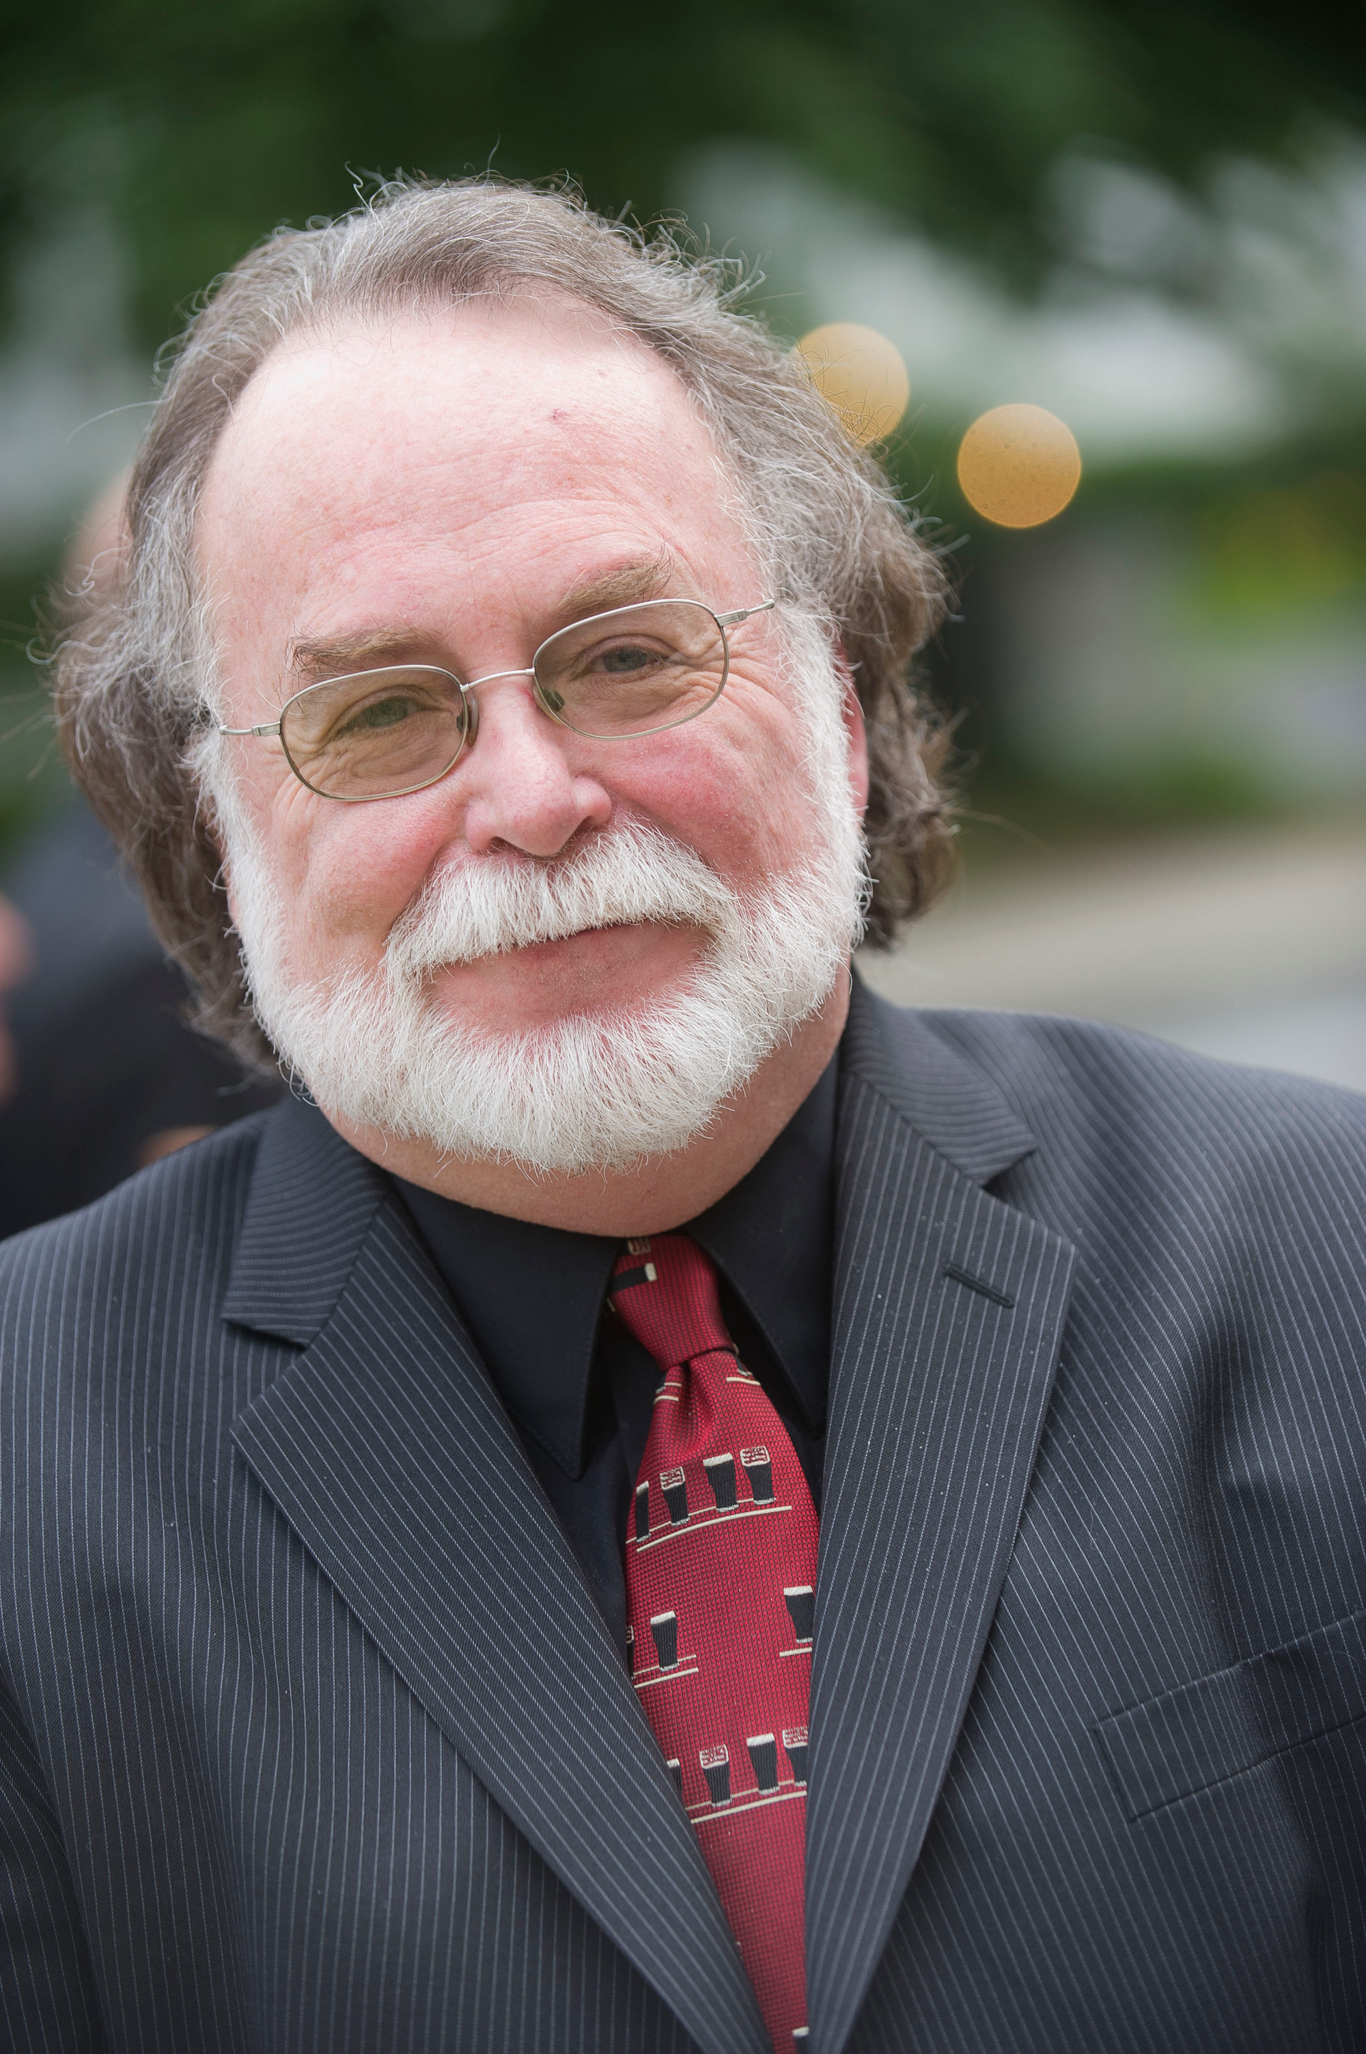 Mark St. Germain (Playwright) FREUD’S LAST SESSION – ran two years Off-Broadway closing July 24th, 2012. Open in Argentina since January 2012 and in repertory in Sweden, Denmark with other international productions opening throughout the world in 2014. His play DR. RUTH, All The Way, premiered in July, 2012 at the Barrington Stage Company in the Berkshires, transferred to Hartford Theaterworks and then moved to the Westside Theater, NY. Scott and Hem in the Garden of Allah co-premiered the Summer of 2013 at the Contemporary American Theater Festival and Barrington Stage Company. His play The Best of Enemies, produced by the Barrington Stage Company, is now being produced throughout the country. The Fabulous Lipitones, a musical comedy co-written with John Markus, premiered at the Theatrical Outfit in Atlanta in summer, 2013, and then at Goodspeed Opera House, before being done by many theaters in 2014. Mark’s plays include Camping with Henry and Tom (Lucille Lortel and Outer Critics Circle Awards), Ears On a Beatle, The God Committee and Out of Gas on Lover’s Leap. Television work includes Writer/Creative Consultant for THE COSBY SHOW, Dick Wolf’s CRIME AND PUNISHMENT and CAROL (Burnett) and COMPANY. He co-wrote Director Carroll Ballard’s film DUMA and produced and directed the documentary MY DOG, An Unconditional Love Story, with Richard Gere, Glenn Close, Edward Albee and others. He’s written for Universal, Scott Rudin Productions, and several other studio and indie films. Mark wrote the Tammy Wynette Musical STAND BY YOUR MAN, which began at the Ryman Theater in Nashville. With composer Charles Strouse he co-wrote the book for his adaption of Dreiser’s AMERICAN TRAGEDY. With composer Randy Courts Mark has written the perennial musical THE GIFTS OF THE MAGI as well as JOHNNY PYE AND THE FOOLKILLER (AT&T Award Grant, and JACK’S HOLIDAY at playwrights horizons. Mark wrote the award winning children’s book “THREE CUPS”. Mark is an Associate Artist of the Barrington Stage Company, recipient of the William Inge Festival’s New Voices Award and a member of the Dramatists Guild and the Writer’s Guild East. He is an alumnus of New Dramatists.

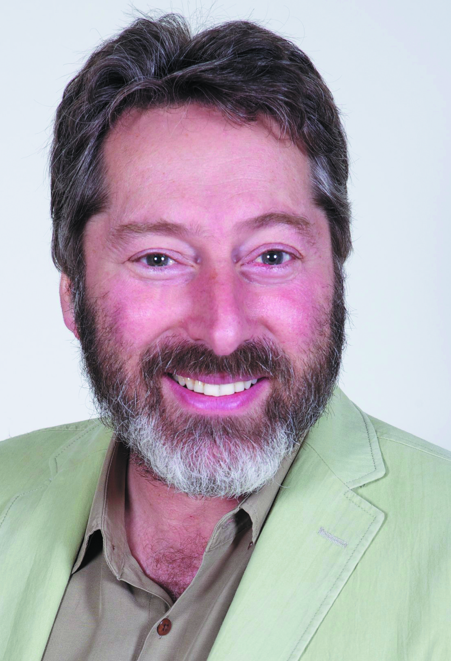 David Ellenstein (Director) Born into a theatrical family, David has worked in theatres across the country. Before joining North Coast Rep in 2003 he served as Artistic Director for the Los Angeles Repertory Company and the Arizona Jewish Theatre Company (AJTC). A veteran of over 200 theatrical productions, directorial favorites include: North Coast Rep – Words By Ira Gershwin, Faded Glory (World Premiere), Mandate Memories (World Premiere), Becoming Cuba (World Premiere), Time Stands Still, Words by: Ira Gershwin and the Great American Songbook (World Premiere), Two by Pinter: The Lover and The Dumb Waiter, HENRY IV Part 1, Heroes, My Name is Asher Lev, The Drawer Boy, Becky’s New Car, Ghosts, The Tempest, Talley’s Folly, Over the Tavern, Old Wicked Songs, The Dresser, Jacques Brel is Alive and Well and Living in Paris, Madagascar, A Shayna Maidel, The Honky Tonk Angels, Rashomon, A Moon for the Misbegotten; Tuesdays With Morrie; Collected Stories; Halpern and Johnson; Romeo and Juliet; Amy’s View; Einstein Comes Through (also co-author); The Chosen; A Life in the Theatre; Story Theatre and Charley’s Aunt. Coconut Grove Playhouse - Sonia Flew starring Lucy Arnaz; Halpern and Johnson starring Hal Linden and Brian Murray. Papermill Playhouse - The Chosen starring Theodore Bikel and John Lloyd Young. Portland Stage - Halpern and Johnson. Renaissance Theatre - Long Day’s Journey Into Night. Actor’s Theatre of Phoenix – Rabbit Hole. Alabama Shakespeare Festival - Rocket City (World Premiere) and Honky Tonk Angels. Laguna Playhouse - Alexandros (World Premiere). Southwest Shakespeare Company - Cyrano de Bergerac. AJTC - Awake and Sing. Meadow Brook Theatre - A Christmas Carol. Portland Rep - Conversations With My Father and Gaslamp Quarter Theatre - A Shayna Maidel.
This artist is sponsored by Lorraine Stamoulis Surnamer

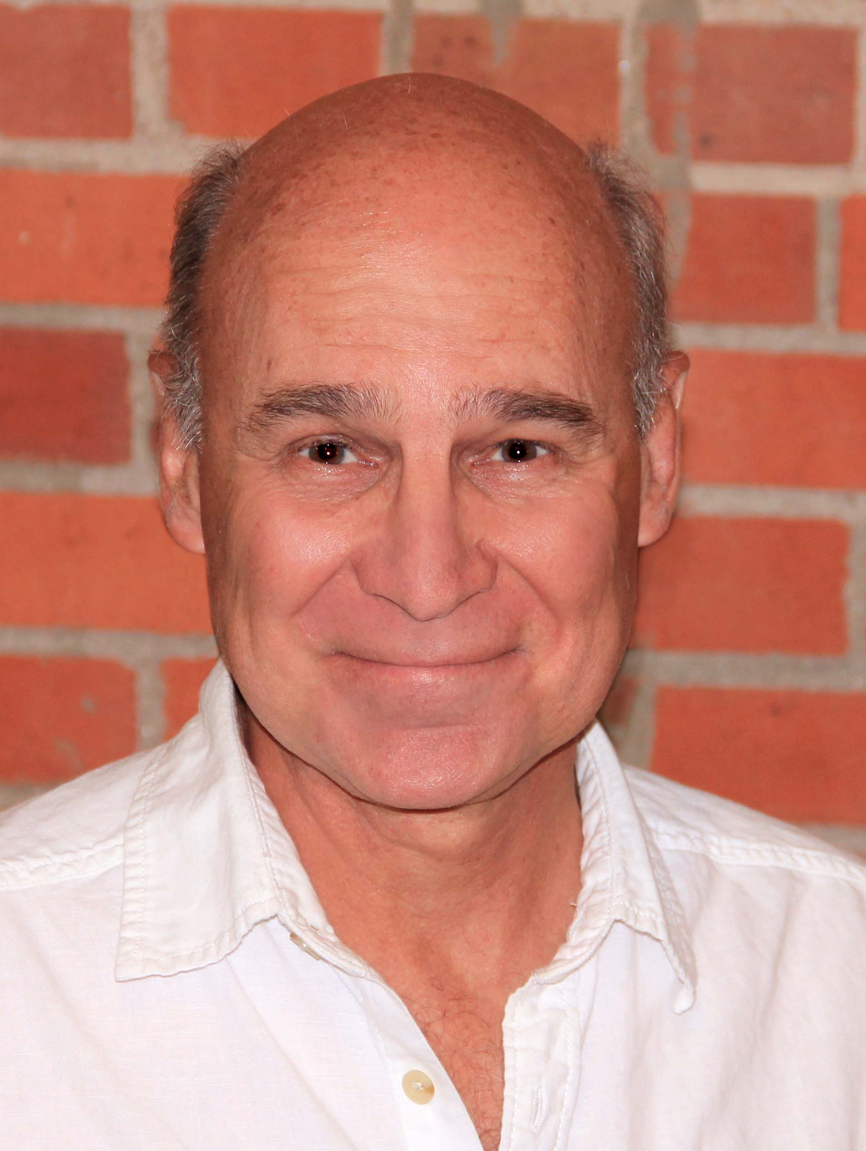 Michael Santo* (Sigmund Freud) is making his North Coast Rep debut. San Diego theatre credits include Oliver in Pentecost at The Old Globe. Most recently he played a season with the Denver Center Theatre Company appearing in Death of a Salesman, Jackie & Me and Shadowlands, and roles in Wallenstein and Coriolanus at the Shakespeare Theatre in Washington D. C.. Previous roles include Sherlock Holmes in Holmes & Watson at the Milwaukee Repertory Theatre, Pater in the West Coast Premiere of Invention of Love and Antonio in The Tempest for American Conservatory Theatre, Welch in God of Hell for Magic Theatre, Andre Said in …” said Said for Alliance Theatre Company, Walter in The Price for Aurora Theatre, Matt in Talley’s Folly at Pasadena Playhouse, Lord Queensberry in the West Coast Premiere of Gross Indecency at Theatre On The Square and Geronte in Scapin with the Utah Shakespeare Festival. Other theatres include Marin Shakespeare, Arizona Theatre Company, Seattle Repertory Theatre, Intiman Theatre, Oregon Shakespeare Festival, Cincinnati Playhouse in the Park, Cleveland Playhouse, Hartford Stage, San Jose Repertory Theatre, TheatreWorks, Great Lakes Theatre Festival, Berkeley Repertory Theatre, The Empty Space, A Contemporary Theatre and Portland Stage Company.
This artist is sponsored by Molli & Arthur Wagner

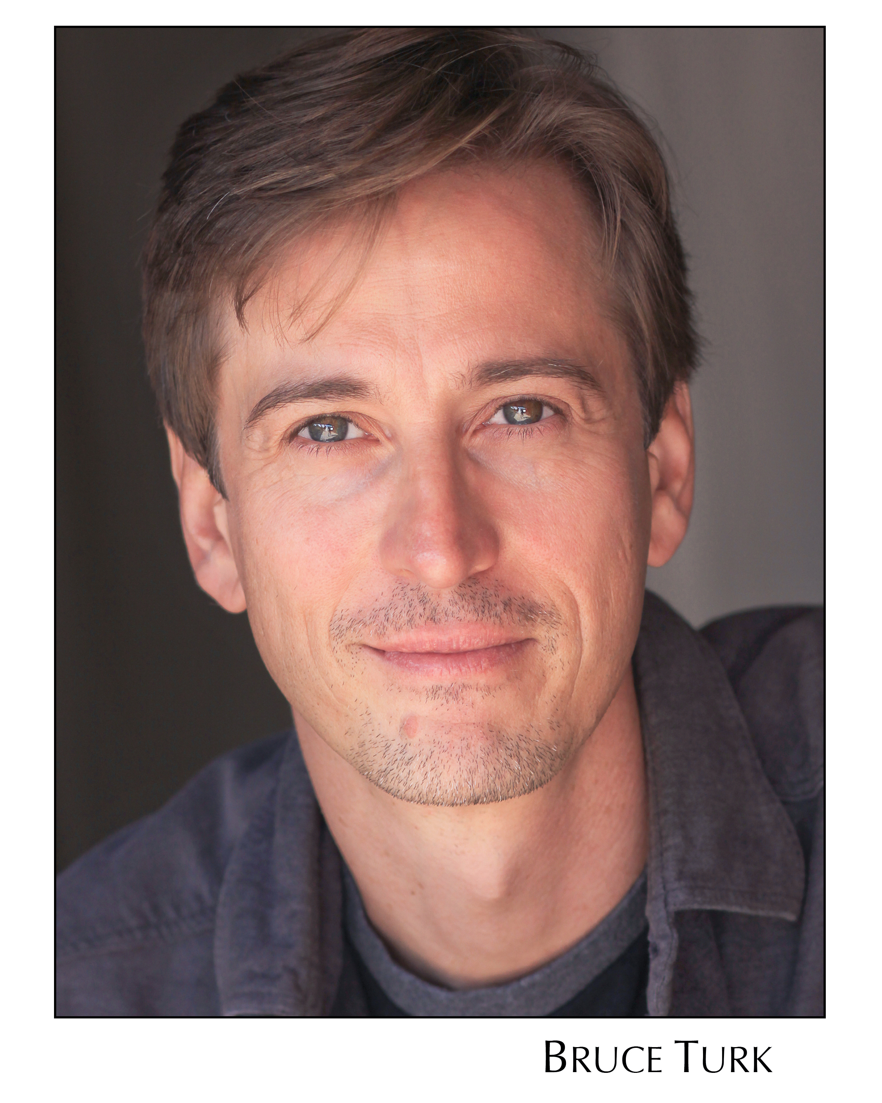 Bruce Turk *(C. S. Lewis) appeared as John Barrymore in NCR’s production of Faded Glory. He trained and performed regularly in Japan as a resident member of Tadashi Suzuki’s Acting Company Mito. He has worked extensively with Julie Taymor, appearing On and Off Broadway in her productions of Titus Andronicus, Juan Darien, and The Green Bird, in the title role. Other New York credits include Faust, King John, and Pericles at the Brooklyn Academy of Music. His regional credits include seasons and productions at the Goodman Theatre, McCarter Theatre, Seattle Repertory, Denver Center, Cincinnati Playhouse, La Jolla Playhouse, The Shakespeare Theatre, Shakespeare Santa Cruz, and many more. San Diego audiences have seen his work in fifteen productions of Shakespeare at the Old Globe Theatre, where his many roles have included the Fool, Grumio, Aguecheek, Ford, Parolles, Claudius/Ghost, Antipholus, and Leontes, for which which he received the San Diego Critics’ Craig Noel Award. A resident artist at Hartford Stage, he was nominated for the Connecticut Critics Circle Award for his portrayal of Malvolio and recently received Theatre Communication Group’s Fox Fellowship for Distinguished Artists. He is a graduate of Northwestern University.
This artist is sponsored by Roger & Nancy Moore

Cindy Rumley* (Stage Manager) credits include Mandate Memories, Dames at Sea, Two By Pinter, and Visiting Mr. Green with North Coast Rep. Snapshots with The Pico Playhouse, Bye Bye Birdie with San Diego Musical Theater, and Conference of the Birds with The Moscow Art Theater. Cindy has worked as a production assistant at North Coast Rep for Heroes, My Name is Asher Lev, 5 Course Love, King O’ the Moon, and The Drawer Boy. Cindy holds an M.F.A in stage management from UC Irvine and is a member of Actor’s Equity Association. In her free time, Cindy enjoys being married to the amazing Mr. Aaron Rumley.
This artist is sponsored by Jay & Julie Sarno

Marty Burnett (Resident Scenic Designer) Marty begins his 22nd season as Resident Designer/Technical Director at North Coast Rep. He has designed the last 150 shows. Other venues include Laguna Playhouse, Portland Stage Company, Drury Lane (Chicago), Claridge Hotel (Atlantic City), Union Plaza, Sahara Hotel, Hacienda in
Las Vegas, Coronado Playhouse, Scripps Ranch Theater, Harrah’s Lake Tahoe. Marty is a proud alumni of Creighton University in Omaha, Nebraska.

Matt Novotny (Lighting Design) recently designed the lighting for Romance Romance, Faded Glory, Mandate Memories, The School For Lies, Who Am I This Time?, Broken Glass, Man with a Load of Mischief, Perfect Wedding, Becoming Cuba, The Odd Couple, Time Stands Still, Educating Rita, The Underpants, Dames at Sea, Two by Pinter: The Lover and The Dumb Waiter, THIS, Visiting Mister Green, Lend Me a Tenor, Five Course Love, My Name Is Asher Lev, King O’ the Moon, Ghosts, Glorious, I Love You Because, Old Wicked Songs, Rabbit Hole, Shipwrecked!, The Dresser, Don’t Dress for Dinner, Mornings at Seven, Baby and Rashomon at North Coast Rep. He’s currently the Director of Production for Lyric Opera San Diego. Lighting designs include: Iolanthe, The Merry Widow, The King and I, Countess Maritza, and The Mikado. San Diego: Das Barbecu, The Wiz, West Side Story and Rumors. Regional: Yankee Doodle Dandy (Seattle), Noises Off! (Boston),The Game, (Washington D.C.) and Primal Twang, a guitar concert featuring six Grammy-winning artists. Matthew holds a B.A. in Technical Theatre from San Diego State University, and an M.F.A. from Boston University.

Alina Bokovikova (Costume Design) is thrilled to work with North Coast Repertory Theatre again. Her recent design credits here include: Romance Romance, Mandate Memories, The School For Lies, Broken Glass, Words By, The Underpants, THIS, Henry IV. She has designed about 50 different productions including A Doll’s House (The Old Globe Theatre), References to Salvador Dali Makes Me Hot, A Man, His Wife, and His Hat and A Raisin in a Sun (MOXIE Theatre), The Playwrights Project, Excavating Escondido, Hedda Gabler, Joe Turner’s Come and Gone, Camino Real (Patté Award) (La Jolla Playhouse and UCSD). She loves to experiment with everything: musicals, The Great American Trailer Park Musical, Beehive; film, Stereoblind; the ballet, Les Noces; and opera, La Traviata. Ms. Bokovikova has an M.F.A. in Costume Design from UC San Diego and a Masters Degree in Education from Russia. She is an instructor of costume design at UC San Diego and history of costume at Fashion Institute of Design & Merchandising.

Melanie Chen (Sound Design) is a freelance sound designer, currently residing in San Diego. West Coast credits: Summer Shakespeare Intensive: Julius Caesar & Comedy of Errors (The Old Globe); Dance of the Holy Ghosts (Ubuntu Theatre Company in San Francisco); Words By Ira Gershwin, Romance/Romance, Faded Glory, Mandate Memories, Becoming Cuba (North Coast Rep); Passion, Bug, reasons to be pretty, Bengal Tiger at the Baghdad Zoo, Grey Gardens, Blasted(Craig Noel Nomination), Angels in America (Craig Noel Award), Body Awareness, The Lieutenant of Inishmore, Dr. Jekyll & Mr. Hyde, Jack Goes Boating (ion theatre company); Boys & Girls (Diversionary Theatre);Crumbs from the Table of Joy (Moxie Theatre); As You Like It, The Tempest, One Flew over the Cuckoo’s Nest(New Village Arts). She also assisted designers such as award winning composer Michael Roth and Tony Nominee designer Cricket Myers at the La Jolla Playhouse, San Diego Rep, and South Coast Rep. Up next, she will be composing original music for East West Player's production of Animals Out of Paper, and sound designing for Uncle Vanya at Pomona College and Pericles at The Old Globe. Education: MFA in Sound Design for Theatre & Dance from UC San Diego. www.melaniesound.com

Benjamin Cole (Properties Designer/Set Dressing) is proud to be part of the North Coast Rep family as Artistic Associate. Additional Properties Designs/Set Dressing at NCRT include: Fallen Angels, Romance/Romance, Faded Glory, Mandate Memories.

